E-sit: An Intelligent Tutoring System for Equation Solving

Rawle Prince
Department of Computer Science, Mathematics and Statistics
University of Guyana
Turkeyn, Georgetown, Guyana
Email: rawlep@yahoo.com
Abstract
Intelligent Tutoring Systems (ITS) are versatile computer programs used to teach students, usually on a one-on-one basis. This paper describes a prototypical ITS that teaches linear equation solving to a class of 11 – 13 year olds. Students must interactively solve equations presented in a stepwise manner. At each step the student must state the operation to be performed, explain the sort of expression on which the operation will be performed and enter their attempt. The ITS also includes a game as a motivational agent. An impromptu evaluation was done in one session with the target class. The results were promising.

Keyword: immediate operations

1. Introduction
Intelligent Tutoring Systems provide active learning environments that approach the experience the student is likely to receive from working one-on-one with an expert instructor. ITS have been shown to be highly effective in increasing students’ performance and motivation [4]. Research has shown that one-on-one human tutoring offers significant advantages over regular classroom work (Bloom, 1984). ITS offer the advantage of individualized instruction without the experience of one-on-one human tutoring [14] and has been proven very effective in domains that require extensive practice [9].
Most of the research in Intelligent Tutoring System has been done in developed countries. This paper reports on an attempt, at the undergraduate level, to deviate from this tradition. E-SIT (Equation Solving Intelligent Tutor), a prototypical ITS for solving single variable algebraic equations, was developed in Guyana, a third world country in South America. The aim was to demonstrate that ITS can be useful, in third world countries.
E-SIT was designed for a particular class of junior high school students (students in the 11 - 13 age group) of a Guyana secondary school. A subset of the equations introduced in the class forms E-SIT’s problem base, such as expressions with one or two variables (x). A computerized version of a popular board game in Guyana is used as a motivational agent.
An unplanned evaluation was done in an attempt to compare data gathered using a restricted version of E-SIT (excluding the motivational game, student modeller and intelligent pedagogical agent) and the completed version. Although not conclusive, the results are mentioned.

2. Design Issues
The design of the system involved accounting for two very different tasks. The first was to create a model of the teacher’s domain knowledge. This included:
- Determining when and how to execute various operations.
- Detecting errors in students’ attempts and giving appropriate feedback.
The second task was to provide an easy to use interface with a built-in parsing tool that allowed students to express equation in a familiar manner.
Both of these tasks could have been accomplished using procedural techniques and languages. Of concern was modeling the domain knowledge. A significant number of rules needed to be considered. A vast number of statements like:
If (condition_x) … do action_x ()
seemed esthetically displeasing and difficult to maintain. In addition, use of a procedural language would have required, apart from the definition of rules, the construction of:
- A pattern matcher for the conditions
- Execution logic for the actions
- A search mechanism to find the matching rules
- A looping procedure
Prolog makes all of this unnecessary. In prolog, rules and facts can be expressed with little regard for procedural details. Prolog also has the capacity to perform ‘i’, ‘iii’ and ‘iv’ above with relative ease via unification (i), backtracking (iii) and recursion (iv). Additionally, prolog has a built-in parser called Definite Clause Grammar (DCG) that allows language rules to be specified and translated into prolog terms.
Prolog was therefore used to construct the expert system, which models the domain knowledge, and the parsing tool. This forms the “back-end” of E-SIT. Visual Basic was used to construct a “front-end” responsible for managing the user interface (described in a later section) and other miscellaneous tasks. Integration was facilitated by Amzi! Prolog and Logic Server, which supports easy integration with other high-level languages.

3. E-SIT: Equation Solving Intelligent Tutor

3.1 Problem Categorization and Representation
Linear equations can be expressed in an infinite number of ways providing there is no limit to the occurrences of the variable term (s) or constants in the expression. Correspondingly, there is no fixed methodology for classifying such problems. Investigations revealed that the students’ major problem area was solving equations, which contained negative terms (minus signs). For this tutor, problems have been considered in four categories according to the occurrences of negative terms. This categorization is depicted in table 1.
Problem Example | Category
4x = 7x + 5 | 1: No minus sign
5x = 9 - 12x | 2: One minus sign
7x - 18 = -9 | 3: Two minus signs
-12x = -3x - 7 | 4: Three minus signs

Table 1 Examples of problems in E-SIT.
Problems presented in E-SIT are randomly generated strings of characters representing words over an alphabet of characters. Words are structured in a modified language (L) for mathematical expressions. The alphabet and language are depicted in figure 1.
The alphabet of L is the set: {0, 1, 2, 3, 4, 5, 6, 7, 8, 9, x, =, +, -, \, /}
The Grammar for the language of linear equations
expr → term, restexpr.
restexpr → = “=”, term.
term → factor, resterm.
factor → num, “x” |”x” |num |”+”, factor|”-“, factor.
restterm → divop |“+”| ”-“.
divop → “\” | ”/”.
num → x ε Z, 0 ≤ x < 100.

Figure 1 Alphabet and language of E-SIT

3.2 User Interface
The user interacts with E-SIT through a graphical user interface (GUI). The GUI consists of four screens:
- A main screen - users can choose all operations and view solutions from this screen (see figure 2).
- Explanation screen - shows options for explanations to operations (see figure3).
- A model screen - shows the user (student) model (see figure 5).
- A game screen - shows the game when it is activated (see figure 4).
The main interface is depicted in figure 3. Brief instructions relevant to the current problem, the current problem and a simplified version of the problem, based on the last correct operation on the problem, are clearly displayed at the top of the main interface. Immediately below this updated problem is a progress bar, which indicates the student’s progress in solving the problem. Below this is the operations panel. Buttons to initiate operations, hints and an option for discontinuing the problem are contained in this panel (discontinuation of the problem would be relevant if the next “immediate operation” would result in a division by zero).
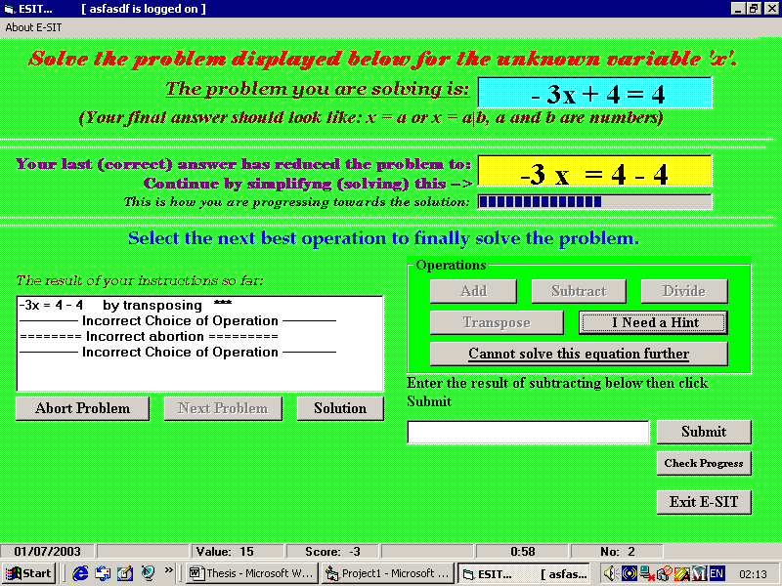
Figure 2 E-SIT’s main screen.

Left of the operations panel are the instruction log and buttons to:
  - Select another problem
  - Abort a problem and
  - View the solution to a given problem.
Below the operations panel are the input space and buttons to submit an input, check progress (view the model screen) and to exit the program.
The student interacts with the system by clicking on buttons and entering input into the space provided via the keyboard.
Motivation is provided in two ways. Firstly, whenever a correct operation is selected, an explanation is submitted or a solution is entered, points are added to, or deducted from, the student’s score. Points are added for correct responses and deducted for incorrect ones. The number of points added, or deducted, depends on the process (selecting an operation, explaining or typing an answer) the student executes. Each problem is valued fifteen points and each takes three stages (transpose, add/subtract and divide) to solve. Selection of an operation is worth 1 point, while explanations and input of user result are worth 2 points each. Explanation is done in one of the sub screens. Figure 3 depicts the interface with the explanation screen activated.
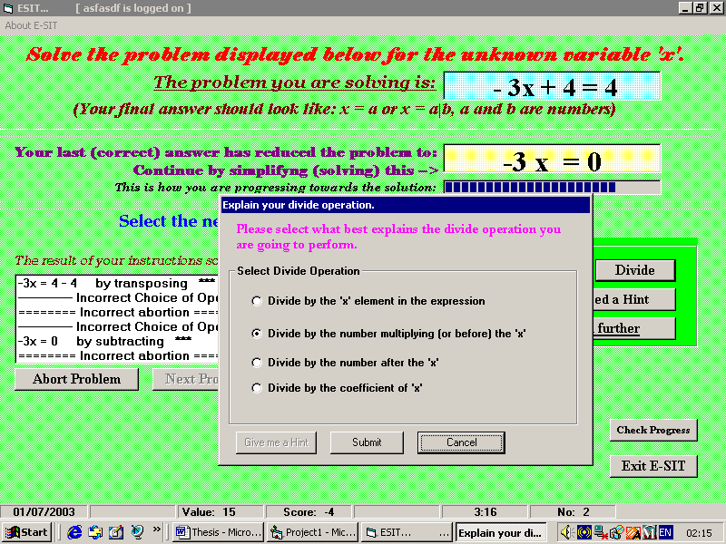
Figure 3 E-SIT’s explanation screen activated.
Secondly, students can have a chance to play a game. The game, “Chick-Chick” is presented in another sub screen.
“Chick-Chick” is a board game played among children in Guyana. The game is played against a dealer who shakes three fair dice in a bowl. Players must wager on the numbers they believe will appear on the face of any dice. If the number(s) on which a wager is placed appears, the player’s winnings corresponds to the amount of his wager times the number of occurrences of the number (s). Otherwise, he looses that amount. Wagers are usually in the form of rubber bands.
In E-SIT “Chick-Chick” is activated for one minute after the first five problems have been completed, regardless of the performance of the student. Subsequent activations may occur on every sixth request for a problem. Activations depend on a student’s improvement over the previous five problems. The conditions for activation and the subsequent duration of the game are determined as follows:
- Improvements > 5% to 10%: thirty seconds.
- Improvements > 10% to 15%: one minute.
- Improvements > 15% to 20%: ninety seconds.
- Improvements >20%: two minutes.
- If the student’s score is >= 90% but s/he has not mastered the domain: two minutes.
If the student has mastered the domain: E-SIT exits and “Chick-Chick” is activated permanently. A student is considered a master if their score in every problem category is above ninety percent.
Figure 4 depicts E-SIT’s interface with “Chick-Chick” activated.
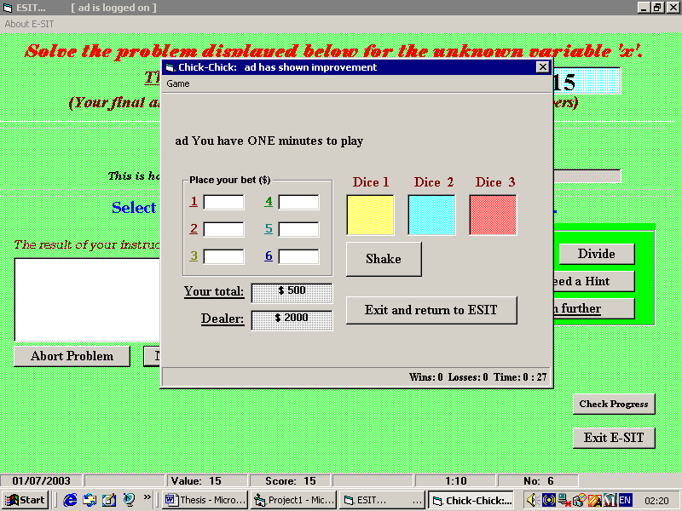

Figure 4 E-SIT’s game screen.

E-SIT has an open student model [7]. This is depicted in Figure 5. The student can see his/her competence at: operations, stages of problem solving (operation selection, explanation and solution), and problem categories.

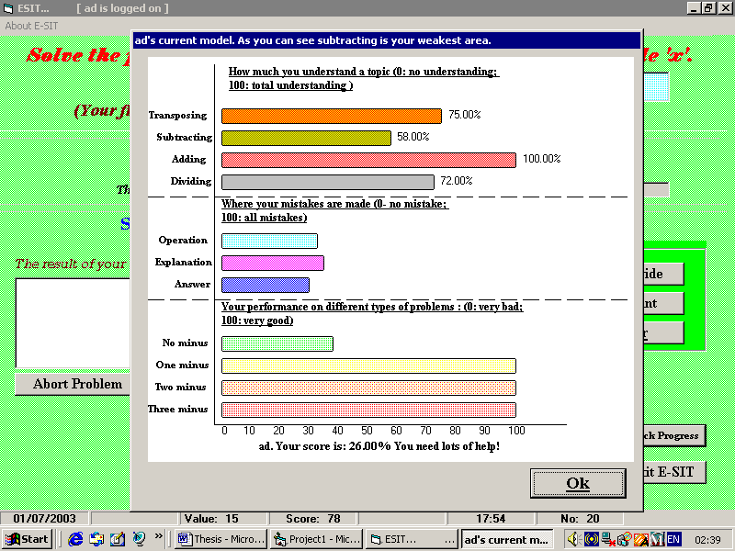
Figure 5 E-SIT’s progress screen

3.3 Architecture
Figure 6 shows the architecture of E-SIT. The domain expert is a representation of the teacher’s knowledge. The ‘Input Validater’ (IVL) determines the validity of a students’ entry before the Evaluator (Evl) considers it. The Evaluator determines whether the student’s entry is correct. If an incorrect entry is detected the student can consult the Error Explainer (EE) for an explanation of the error. If incorrect entries persist, or the student has chosen to exit the system before they have solved the given problem, the problem solver can be consulted to reveal the solution of the current problem.
Domain Knowledge
Domain Expert
Input ValidaterEvaluatorProblem SolverError Explainer
Student
Modeler
Interface
Student
Model
Tutoring History
Pedagogical Module

Figure 6 E-SIT’s architecture

3.4 Knowledge Representation
Knowledge for the tutor was primarily acquired from sessions with the class teacher. A professional teacher, she made useful suggestions as to what approaches the tutor should take. For example, the tutor refers to variable terms as “unknowns” and constant terms as “knowns”. Additionally, the following methodology was used for solving equations. A student is required to follow a stepwise solution path. The concept of “immediate operations” (IO) is used to describe the ‘best’ operation that can be performed on a mathematical expression to reduce its complexity. Students were encouraged to employ a set of “immediate operations” to arrive at the solution of problems. Suppose, for example, the expression, 3x = 7 – 12x, is given. The “ideal” solution path is to:
- Group the similar terms together: 3x + 12x = 7.
- Add the similar terms: 15x = 7.
- Divide (both sides) by the coefficient of the unknown giving: x = 7/15.
At stage 3, the problem would be solved since no more operations would reduce its complexity. Also, the expected solution, x = “something”, would be achieved. Equation solving is therefore a recursive process of recognizing and executing “immediate operations” until all “immediate operations” have been exhausted, and/or the value of the unknown term has been found. Students were advised to put all elements with x to the left of the equal sign and all numbers to the right.
This methodology was implemented in E-SIT in the following manner. When a student attempts to solve a problem s/he must go through a sequence of steps at each stage, similar to those mentioned. These steps are:
- Select the operation to be performed from among: add, subtract, divide and transpose.
- Explain the operation. From among four possibilities, the student must select the one that best describes what should be done.
- Enter what s/he believes will be the resulting expression after the operation was performed.
Step ‘a’ involves recognition of the operation while step ‘c’ involves execution of the operation. Step ‘b’ is an additional step included in E-SIT that requires students to specify further details of an operation. Step ‘b’ can only occur if ‘a’ was successful. Similarly, step ‘c’ can occur only if step ‘b’ was successful. After a stage is completed, the problem is [re] assessed to determine the operation that should follow. To illustrate, the following prolog predicates were used to determine if a subtraction can be performed.
exp_can_sub(StringIn) :-
string_to_plist(StringIn,NumList), % converts string to list of characters
can_sub_list(NumList).

can_sub_list(List) :- retractall(problem_type(_)),
sub(List,_), % subtract the expression 1)
countmem(x,List,2), % x occurs twice
asserta(problem_type($xsub$)), !. % set code for operation

can_sub_list(List) :- retractall(problem_type(_)),
sub(List,_), % subtract the expression
countmem(x,List,1), % x occurs once
asserta(problem_type($nsub$)), !. % set code for operation
If a query to exp_can_sub\1 succeeds, a fact (problem_type\1) is asserted that describes the problem (i.e. the kind of operation that must be performed). Nsub (for “knowns”) and xsub (for “unknowns”) defines what must be subtracted. A similar approach is used for all other operations except for division. Division can either occur or not occur. There are thus seven possible explanations for a given operation.

3.5 Problem Solving
E-SIT uses the same methodology described above to solve problems. The implementation is illustrated by the following predicates:
solve(Problem,Solution,OperationType) :-
string_to_plist(Problem,OpList),
operate(OpList,SolList,OperationType),
plist_to_string(SolList,Solution),!.

operate(InList,SolutionList,$transposing$) :- transpos(InList,SolutionList).
operate(InList,SolutionList,$subtracting$) :- sub(InList,SolutionList).
operate(InList,SolutionList,$adding$) :- add(InList,SolutionList).
operate(InList,SolutionList,$dividing$) :- divide(InList,SolutionList).

A query to solve\3 executes the first “immediate operation”. Repeated calls to solve\3 effect the next “immediate operation” until the query fails. A failed query to solve\3 would indicate that the problem has been solved, or the problem cannot be solved. The following algorithm can summarize this procedure.
While any “immediate operations” exist
If is divide operation and divisor is zero then
Output message
Else
Execute operation
Output result
End if
End while.

Figure 7 shows a problem solved by E-SIT.
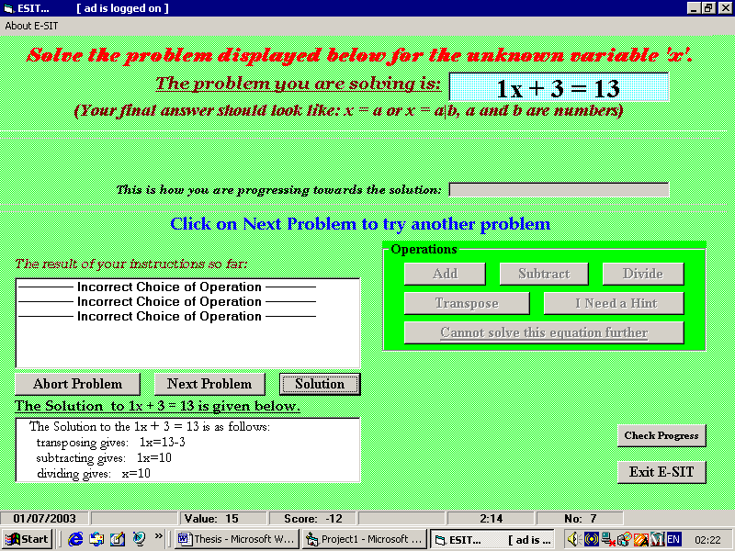
Figure 7. A problem solved by E-SIT.

3.6 Error Representations, Explanation and Student Modelling
There are four categories of errors in E-SIT. These are:
- Incorrect Operation Errors
- Incorrect Explanation Errors
- Incorrect Solution Errors
- Invalid Solution Errors
Incorrect Operation Errors occur when an incorrect operation, specific to a problem or sub-problem, is selected. Recall that problem solving constitutes executing IOs recursively until a solution is found. Recall also that there are at most three IOs per problem. Let RO (RO є {add, subtract, divide, transpose}) denote the required operation for a problem or sub-problem at IO_{j} (1 ≤ j ≤ 3) and let SOP denote the operation that was selected by the student for IO_{j}. An incorrect operation error occurs if SOP ≠ RO.
Incorrect Explanation Errors occur when a wrong explanation is submitted while Incorrect Solution errors and Invalid Solution errors result from errors detected in the answer typed in the (input) space provided (see figure 2). Violations of the grammar (section 2) result in an invalid solution error while incorrect attempts at a problem or sub-problem result in incorrect solution errors.
There are four subcategories of 1,3, and 4, and seven for 3. These correspond to the operation (add, subtract, multiply or divide) to be executed, in the case of 1,3,and 4. Table 2 illustrates the errors and their corresponding codes.

Code | Corresponding Operation | Error Category
E1 | Transpose | Operation Selection
E2 | Add | Operation Selection
E3 | Subtract | Operation Selection
E4 | Divide | Operation Selection
E5 | X_Transpose | Explanation
E6 | N_ ranspose | Explanation
E7 | X_Add | Explanation
E8 | N_ Add | Explanation
E9 | X_Subtract | Explanation
E10 | N_Subtract | Explanation
E11 | Divide | Explanation
E12 | Transpose | Incorrect Solution
E13 | Add | Incorrect Solution
E14 | Subtract | Incorrect Solution
E15 | Divide | Incorrect Solution
E16 | Transpose | Invalid Solution
E17 | Add | Invalid Solution
E18 | Subtract | Invalid Solution
E19 | Divide | Invalid Solution

Table 3. Errors in E-SIT. N refers to knowns; X refers to unknowns.
E-SIT responds to Incorrect Solution errors in the following manner, with a yes/no message box (opr ε {“add”, “subtract”, “divid” or “transpos”}).
S: Your attempt at [opr]ing is incorrect. Would you like E-SIT to investigate?

Selecting ‘yes’ invokes the error explainer. To explain errors E-SIT analyses the incorrect solution for various patterns. Two kinds of analysis occurs:
- Grammatical Analyses and
- Conceptual Analyses.
Grammatical Analysis determines if the student’s entry has violated grammatical rules that define appropriate entries for each operation. Modifications to the grammar in section 3.3 are used to determine valid inputs. These modifications are shown in Figure 8.

Transpose

trans_result = tfact, resttrans.
resttrans= “=”, rhstrans.
rhstrans = num | num, addop, num.
rhstrans --> addop, rhstrans.
tfact --> num, “x”| addop,tfact.
tfact --> num,id,tfact.
addop = “+”|”-“
Addition/Subtraction

add_result = lhs,restadd.
restadd = “=”, rhs.
rhs = num | “+”,rhs | “-“,rhs.
lhs = num, “x” | “+”,lhs | “-“,lhs
Division

div_result = “x”, rdiv.
rdiv = “=”l, rem.
rem = num | num, “/ “,num
rem = addop, rem.
addop = “+”| “-“

Figure 8 Modifications to grammar for results of operations
Conceptual Analysis determines errors in the student’s solution. If an incorrect answer was entered, the system attempts to discover and report the student’s misconception. If no misconception can be found, this is also reported. For example, if the problem - 12x = 5x + 9 was given and the student enters - 12x + 5x = 9. E-SIT would return:
S: You did not change the sign after transposing the unknown!

3.6.1 Student Modelling
Student modelling is facilitated by the retention of error records in bug libraries. Once an error is detected, an error record is instantiated and retained. Examples of error records are shown in table 3. Ones indicate the error that was instantiated and zeros, errors not instantiated.
Rec # | E1 | E2 | E3 | E4 | E5 | E6 | E7 | …………….. | E16 | E17 | E18 | E19
1 | 0 | 0 | 1 | 0 | 0 | 0 | 0 | …………….. | 0 | 0 | 0 | 0
2 | 0 | 0 | 0 | 0 | 1 | 0 | 0 | …………….. | 0 | 0 | 0 | 0
3 | 0 | 0 | 0 | 0 | 0 | 0 | 0 | …………….. | 0 | 0 | 0 | 0
Table 3 Error records. The last record is a null record
Error records with no instantiated errors are considered “null records” (rec # 3 in table 3). These are retained when no error is detected for the duration of a problem. They facilitate student modelling in the following manner. Suppose the null record in table 3 was not retained. The system’s belief that the students will make error E3 would be P (E3) = ½ . Now, suppose the student has entered the correct solution to the sub-problem, the null record (record # 3) is retained. The system’s new belief that the student would make error E3 would be P(E3) = 1/3.
A student’s competence in an operation is determined by the student’s ability to perform the sequence of steps described in section 3.4. The system’s belief in a student’s competence at transposing P(Tr), for example, would therefore be represented as (see table 2):
P (Tr) = P(E1) U P(E5) U P(E6) U P(E12) U P(E16), (1)
Error records are sensitised to a class (C) corresponding to the category of the problem being solved. C1 – C4 corresponds to [problem] categories 1 – 4 respectively. Hence (1) is in fact:
P(Tr) = ∑ _{x} P (Tr\C_{x}) (1 ≤ x ≤ 4) (2)
E-SIT also retains a long-term (student) model. Long-term models are used to build an enduring representation of the student [11]. The long-term model retains probabilities of each error, P(Ex) {1 ≤ x ≤ 19} in table 3. The long-term model is updated by a request for another problem (by clicking on ‘Next Problem’ – figure2). This is accomplished via the following algorithm:
New State = Old State *0.6 + Recent State *0.4
‘Old State’ represents the probability calculated before the previous problem was requested, while ‘Recent State’ represents the probability calculated after errors from the previous problem have been considered.
The long-term model is retained for the duration of the student’s session. It is saved when s/he logs off and is retrieved when s/he logs back on.

3.7 Next Problem Selection
The next problem given to the student is determined in two ways. Firstly, when a new user logs on to the system, s/he is given four “test” problems, one from each category. These are used to give the system an overview of the user’s competence.
Secondly, if a user has logged into the system before, or the “test” problems have expired, the value of the next problem [category] is determined by predicting the effect of one of the four problem categories on the student. A problem category of appropriate complexity is the one that falls in the zone of proximal development, defined by Vigotsky (1978) [11]. This principle implies that utility should be greater for categories where the student is known to have some difficulty, but not so much difficulty that they cannot solve the problem, and lesser for categories where the student would have too much or too little or no difficulty. A utility function is defined. This utility function is shown in table 4.
Category (X) | U (x)
1 | 0.15
2 | 0.35
3 | 0.3
4 | 0.2
Table 2 Utility functions for problem selection.
Hence the category of the next problem, N, is determined by (U(x) is the utility function):
N = max {Ct_{x} = ∑_{y} P(y\C_{x}) U(x), y ε {add, subtract, divid, transpos}; 1 ≤ x ≤ 4, x є N}
Once the category is determined, the problem is generated randomly, according to criteria outlined in section 3.

3. Evaluation
The evaluation of E-SIT was unplanned. In an attempt to confirm to a methodology for implementing normative ITS [11], a data collection exercise was undertaken with a “restricted” version of E-SIT. The “restricted” version contained a problem solver and a problem evaluator, but no student modeller. Problems were randomly retrieved from a problem database and students received feedback on the accuracy of their solutions and invalid entries. The aim was to retrieve population parameters of students’ performance on errors in order to instantiate a belief network student modeller. This approach was subsequently abandoned because of resource constraints.
A follow up session was arranged with the completed version of E-SIT. The aim was to observe if the pattern of errors would remain consistent. Students’ participation in there sessions was not mandatory, so many students did not partake. General results from the two sessions are summarized in table 4.

 | Restricted version | New version
No. of Students | 11 | 6
No. of Errors | 704 | 217
Errors per student | 64 | 31.17
Table 4 Summary of results from evaluations
Quite noticeable in the second evaluation was students’ enthusiasm about the game. Three students showed enough improvement to earn another chance to play for thirty seconds while two students earned another chance to play for one minute (see section 3.2). One noticeably weak student did not earn another chance at the game.
Due to the [small] sizes of the sample spaces and the impromptu nature of the evaluation, the results are only considered as an indication that further investigations are necessary.

4. Future Work and Conclusion
This is known to be the first research of this type done in Guyana.
The next step in this project is to conduct further evaluations to retrieve more details of students’ interaction with the tutor (for example the time students take on each problem, the number of errors per problem, the number of hints requested per problem). This information can be used to calculate students’ probability of making an error over time, averaged over all errors and all students, as a possible measure of learning.
The tutor can be further enhanced so that:
- Students gat an opportunity to work on their weak areas (transposing adding, subtracting or dividing) individually and to receive assistance if need be.
- Students are allowed to choose their method of problem solving. For example, whether to use the existing stepwise method or to solve the entire problem and have the system analyze the solution for errors.
Additionally, the method of student modelling used has noticeable weaknesses. A student’s ability to perform an operation is reflected in his/her ability to execute the steps described in section 3.4. A student would not be able to get to step k +1 without being successful step k or k – 1. It therefore stands to reason that a student’s performance at step k would be influenced by their performance at step k-1, which highlights a flaw in E-SIT’s assumption of the independence of each step.
Other techniques of student modelling can be explored. Of particularly interest is the use of Bayesian Networks and decision theoretic strategies for student modelling and problem selection as proposed by Mayo [11].

Acknowledgement
The author would like to thank Dr Antonija Mitrovic of the University of Canterbury, New Zealand, for providing most of the material referenced for this project. Thanks also to Ms Drupatie Jankie for her time, and the School of the Nations Guyana for the use of their computer lab and students.

References
- Alexandris N., Virvou M, Moundridou M. A multimedia Tool for Teaching Geometry at Schools, University of Piraeus, Greece.
- Arroyo I., Beck J E., Beal C R., Wing R., Woolf B P. (2001) Analyzing Students’ responses to help provision in an elementary mathematics Intelligent Tutoring System, University of Massachusetts, Amherst, MA 01003.
- Beal, C.R., Arroya I., Royer J M., & Woolf B P (2003) Wayang Outpost: A web-based multimedia intelligent tutoring system for high stakes math achievement tests, University of Massachusetts-Amherst.
- Beck, J., Haugsjaa, E. & Stern, M. Applications of AI in Education, http://www.acm.org/crossroads/xrds3-1/aied.html
- Do Boulay B., Luckin R (2001) Modelling Human Teaching Tactics and Strategies for Tutoring Systems, Human Centered Technology Research Group, School of Cognitive and Computing Sciences, University of Sussex, BNI 9QH, UK.
- Geobel, R., Mackworth, A., Poole, D. (1998) Computational Intelligence a logical approach. Oxford University Press.
- Hartley, D. & Mitrovic, A. (2001) Supporting Learning by Opening the Student Model, University of Canterbury, Christchurch, NZ.
- Hume, Gregory, D. (1995) Using Student Modelling to Determine When and How to Hint in an Intelligent Tutoring System, Illinois Institute of Technology.
- Koedinger, K.R. (1998) Intelligent Cognitive Tutors as Modeling Tool and Instructional Model. Position paper for the NCTM standards 2000 Technology Conference. Human-Computer Interaction Institute, School Carnegie Mellon University, Pittsburgh.
- Martin, B., Mayo, M., Mitrovic, A. & Suraweera, P. (2001) Constraint-Based Tutors: a success story, University of Canterbury, Christchurch, NZ.
- Mayo, M.J. (2001) Bayesian Student Modelling and Decision-Theoretic Selection of Tutorial Actions in Intelligent Tutoring Systems, University of Canterbury, Christchurch, NZ.
- Mitrovic, A. (2002) An Intelligent SQL Tutor on the web, University Of Canterbury, Christchurch, NZ.
- Mitrovic, A., Martin, B., Mayo, M. (2000) Multiyear Evaluation of SQL-Tutor: Results and Experiences, University of Canterbury, Christchurch, NZ.
- Mitrovic, A. & Suraweera, p. (2001) An Intelligent Tutoring System For Entity Relationship Modelling, University of Canterbury, Christchurch, NZ.
- Psotka, J. & Shute, V. (1995) Intelligent Tutoring Systems: Past, Present, and Future. Jonassen (ed), Handbook of Research on Educational Communications and technology.

Facts are simple statements that describe some state of the knowledge domain (in this case).
This concept is described later in the paper (section 3.4 )
Further use of “unknowns” and “knowns” would be in this context.
A sub problem is a simplified version of a problem that has not been solved. For example, 4x + 4 = 9 would appear as 4x = 9 – 4 after transposing.
P(k) = number of times k was instantiated/number of records.

